Hancock County Substance Abuse Prevention Plan

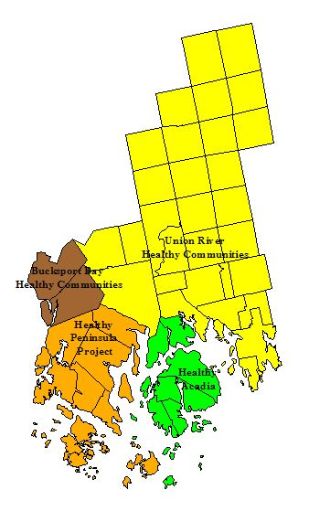
Partners:
- Hancock County Planning Commission
- Hancock County Sheriff’s Office
- Bucksport Bay Healthy Communities
- Healthy Peninsula
- Healthy Acadia
- Union River Healthy Communities

- WEBSITE: www.healthyhancock.org

Revised: 10/21/07
Table of Contents

Executive Summary 4
Introduction 5
The Case for a Coordinated Substance Abuse Prevention Plan 5
How to use the Hancock County Substance Abuse Prevention Plan 6
Strategic Prevention Framework 6
CMCA – A Science Based Intervention Paradigm 8
Methodology for Prevention Planning in Hancock County 9
State of the County 11
Understanding Place 11
Population 11
Economy 13
Conclusions 14
Substance Abuse over the Life Course 14
Protective and Risk Factors for Youth 16
Indicators and Correlates of Substance Abuse – Youth to Young Adults 17
Substance Abuse 17
Illegal and High Risk Activity 20
High School Completion 21
Substance Abuse and Other Criminal Activity 22
Indicators and Correlates of Substance Abuse –Adults 24
Indicators and Correlates of Substance Abuse –Seniors 29
SPEP Outreach Process and Findings 30
A Plan for Substance Abuse Prevention 31
Overview 31
Vision for Hancock County 31
Goals, Intervening Variables and Strategies 32
Resource Matrix for Hancock County 32
1. Underage Drinking 33
2. High Risk Drinking 35
3. Elder Alcohol Abuse 37
4. Illegal Drug Use 39
5. Prescription Drug Misuse 40
6. Marijuana Prevention 41
Connecting Resources to Strategies 42
Types of Organizations 42
Age Groups 42
Intervening Variables 42
Resources 43
Implementation 50
Creating a Work Plan 50
Sample Memoranda of Understanding 51
Appendices 52
Appendix 1: Resource-Intervening Variable Matrix – See attached form and Excel Spreadsheet 52
Appendix 2: Memoranda of Understanding 52
Appendix 2: Health Hancock (Circ. 2005 – Some revisions required) 53

Executive Summary

Hancock County faces serious challenges and opportunities as we grapple with substance abuse and the epidemic of underage drinking. Everyone is affected directly or indirectly by drug and alcohol abuse. Abusers face a myriad of problems, but so do their families, friends and wider communities.

The Hancock County Substance Abuse Prevention Plan (HC-SAPP) provides readers with an overview of the problems we are confronting, a snap shot of people and programs that are working to prevent and resolve problems associated with substance abuse and strategies for reducing problems in the future.

Readers are encouraged to join in the prevention effort. To this end, the plan offers model voluntary agreements that will help us to structure our efforts to prevent substance abuse in the future.

Introduction

The Case for a Coordinated Substance Abuse Prevention Plan
This Substance Abuse Prevention Plan for Hancock County brings together an assessment of our current situation and proposes six major goals addressing a diverse range of concerns:

- Underage Drinking | - Illegal drug use
- High risk substance abuse | - Prescription Drug Abuse
- Elderly Substance Abuse | - Marijuana Abuse

A comprehensive substance abuse intervention plan should include elements of prevention, interdiction, enforcement and treatment. This plan is focused primarily on prevention, but endorses techniques, such as consistent enforcement of laws that have effects beyond prevention.

Hancock County has great needs and many assets to prevent substance abuse. The data presented in the plan suggest that substance abuse, school dropout rates and crime have been increasing in Hancock County. Concentrated local enforcement efforts such as targeting underage drinking parties are effective, but problems often emerge in new locations or new forms.

Even a casual look at the local news points to the regional nature of the substance abuse problem. Drug arrests, often occurring in Ellsworth, involve residents of multiple outlying towns as well as visitors from other states. The supply chain for drugs and alcohol often begins far away, but most often ends where there is a critical mass of customers. Each drug or form of alcoholic beverage has a unique supply chain.

Recognizing that substance abuse is a statewide problem with regional and local consequences, the Maine Office of Substance Abuse is working with the Maine Center for Disease Control to develop regional public health infrastructure to assist local, county and state agencies through coordinated prevention efforts.

The 2006–2010 Maine Substance Abuse Prevention Plan states,

“The goal of this grant is ambitious - to prevent the onset and reduce the progression of substance abuse across the lifespan by taking a public-health approach. To meet these goals, the SPF-SIG is based on outcomes-based prevention efforts that focus at the population-level on the consumption of alcohol and other drugs and their consequences. (OSA SPF, 2006)

How to use the Hancock County Substance Abuse Prevention Plan

This plan is directed to a wide audience. We are all affected by substance abuse and we all have a role in prevention. Local leaders play a particularly important role in creating an open and collaborative atmosphere. Leaders come from many domains, including state and local government, schools, health care, private voluntary organizations, businesses and families. This plan engaged people who work every day in related fields, including substance abuse treatment, law enforcement, community health promotion and substance abuse treatment. While the plan identifies issues, intervening variables and general strategies, it does not prescribe specific actions for all stake holders. We encourage people who are engaged in “doing” this good work to take time to see how their work can fit into the goals, objectives and strategies described here.

Section 1: The State of the County identifies substance abuse trends in Hancock County and related patterns such as crime, education and health. We also consider existing regional programs that are engaged in the effort to prevent substance abuse and reduce the negative consequences where they occur. Where possible, this analysis is presented in relationship to the population “at risk” of substance abuse. This analysis looks at children and teens, young adults, middle age adults and seniors separately where applicable.

Section 2: Programs for Substance Abuse Prevention describes how the public is involved in creating a healthier future. Community and school leaders, community health advocates, business and law enforcement are collaborating to create new programs and better coordinate existing programs to prevent substance abuse. Public participation is a key to understanding the cultural factors related to substance abuse and building our regional cultural competence.

Section 3: Vision, Goals, Objectives and Strategies is a plan for our communities to work together to prevent and reduce substance abuse. The plan concludes with voluntary agreements or memorandum of understanding (MOU) that will help us to structure our efforts to prevent substance abuse in the future.

Strategic Prevention Framework

The Maine Strategic Prevention Framework (SPF) Plan is being implemented through a series of state level initiatives supported at the local level through Strategic Investment Grants (SIG). The Maine Office of Substance Abuse led the effort to write the 2006 Substance Abuse Prevention Strategic Prevention Framework Plan. This plan adopts intermediate and long term outcomes. The SPF provides a framework for local and regional initiatives, but does not prescribe detailed solutions.

Major Outcomes Expected to Result from Strategic Plan

Intermediate Outcomes
- Strengthen state level substance abuse prevention infrastructure
- Strengthen local level substance abuse prevention infrastructure
- Primary and secondary prevention efforts result in positive changes in skills, beliefs, knowledge, attitudes, perceptions and norms within the communities

Long Term Outcomes
- Decrease in alcohol and other drug abuse, including: high risk drinking, marijuana, prescription medications, and methamphetamine
- Decrease in morbidity, mortality, injury, and disability related to substance use/abuse

(source: OSA SPF, 2006)

The state plan stresses scientifically measurable goals and objectives stated as a series of outcomes. The matrix that follows provides a summary of adopted strategies, short-term, intermediate and long term outcomes.

The State Plan targets consumption outcomes:
- Reduce high-risk drinking among Maine youth (12-17).
- Reduce high-risk drinking among Maine young adults (18-25).
- Reduce marijuana use, abuse of prescription medications, and use of other drugs among Maine youth (12 -17)
- Reduce marijuana use, abuse of prescription medications, and use of other drugs among Maine young adults (18-25)
- Slow the spread and reduce the use of methamphetamines in Maine. (While Maine’s SPF SIG will not be funding prevention initiatives around Meth, they will collaborate with other programs to address this)

State-level priorities:

- Enhance data infrastructure and epidemiological analysis capacity
- Coordinate funding streams
- Strengthen the substance abuse prevention workforce
- Integrate substance abuse and other public health prevention efforts

Local-level priorities:

- Conduct county-wide needs assessment; mobilize and builds capacity; and develop a strategic plan
- Implement culturally appropriate evidence-based primary and secondary prevention programs and services
- Monitor and evaluate the process and effectiveness of local grantees
- Train and strengthen a skilled and culturally-competent prevention workforce

CMCA – A Science Based Intervention Paradigm
The Maine Office of Substance Abuse (OSA) engages several science based programs, on of which is known as Communities Mobilizing for Change on Alcohol (CMCA). The CMCA paradigm presented below identifies examples of measurement and intervention for three behavioral and three attitudinal intervention strategies. This paradigm is reflected in goals, intervening variables and strategies presented in this prevention plan.

Changing Attitudes

Adult attitudes and perception of adult attitudes in community
Measurement: adults in the community think substance abuse is wrong
Intervention: Sticker shock

Parental attitudes and the perception of parental attitudes
Measurement: parents think underage substance abuse is “very wrong”
Intervention: Community-based substance abuse awareness campaign – modeling good practices
Social benefits of substance abuse and the perception of social benefits
Measurement: likelihood that one would be seen as “cool” if using alcohol or drugs
Intervention: Social norms marketing and school policies that encourage intervention
Changing Behaviors

Enforcement and the perception of enforcement
Measurement: Likelihood of being caught for violation of laws
Intervention: Consistent surveillance and arrests

Parental monitoring and the perception of parental monitoring
Measurement: likelihood of being caught by parents
Intervention: Parental awareness training

Ease of access and the perception of ease of access

Measurement: citations for selling alcohol to minors
Intervention: Routine retail sting operations, Server Training
CMCA Program for Substance Abuse Intervention

Methodology for Prevention Planning in Hancock County
The five step process for preparing this plan included:

- Assessment

The goal of assessment is to define the scope of substance abuse problems in Hancock County, identifying some causes and consequences. A list of risk factors and protective factors was examined in this context.
- Risk Factors – individual, familial and environmental factors that increase the risk that someone will use drugs.
- Protective Factors – individual, familial and environmental factors that decrease the risk that someone will use drugs.

- Build Capacity

This participatory planning process was designed to bring together organizations engaged in substance abuse prevention and build their capacity through better information, coordination and new resources. Regional prevention programs will depend on greater investment in county and local prevention initiatives. Hancock County is experience significant cultural change placing new demands for cultural competency, such as communicating in multiple languages and reaching new and relatively isolated populations.

- Plan

Regional plans assist county and local organizations to set priorities. This plan is designed to fit within state priorities and address cross-county issues.

- Implement

The participatory process can leverage existing substance abuse prevention programs and partners to implement priority goals, objectives and strategies. Plans have little impact if left on the shelf.

- Evaluate

This plan identifies measurable concerns and measurable objectives. Each objective is a milestone to the long term goal of preventing substance abuse. Completion of objectives and measurement of reductions in substance abuse are the key elements for evaluating this plans effectiveness.

The Maine Strategic Prevention Framework (SPF) employs a logic model (pictured below) that seeks to achieve long-term outcomes through strategic actions leading to short-term and intermediate outcomes.

Components

Strategies
Short-Term Outcomes
Intermediate Outcomes
Long-Term Outcomes
Maine Strategic Prevention Framework (SPF) Logic Model

State

Review and refine existing data to assess sub-state differences and needs
Provide financial support to communities and coordinate funding streams
Provide technical assistance through Prevention Centers of Excellence

Strengthen the substance abuse and prevention workforce
Conduct county-wide needs assessment with partners and develop strategic plan (Steps 1-3)
Implement evidence-based primary and secondary prevention efforts (Step 4)
Integrate substance abuse and other public health prevention efforts
Primary and secondary prevention efforts result in positive changes in:
priority intervening factors (skills, beliefs, knowledge, attitudes, perceptions, norms)
Local prevention efforts are integrated, accessible, culturally competent, and sustainable
Increased state capacity to address substance abuse/use

Strengthened local substance abuse prevention infrastructure

Local

Evaluation (step 5) & Data-Driven Decisions
Provide guidance, funding, and support for local implementation of the 5 SPF steps in a culturally competent manner
Strengthened state substance abuse prevention infrastructure
Increased implementation of evidence-based prevention

Decrease in alcohol abuse and other drug use/abuse including:
- high risk drinking
- marijuana
- prescription meds
- methamphetamine

Consumption
Decrease in morbidity, mortality, injury, and disability related to substance use/abuse
Consequences
Increased local capacity to address substance abuse/use

State of the County

Understanding Place

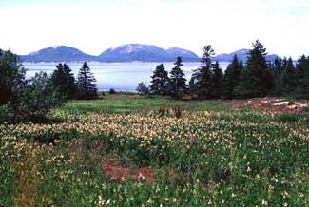
The unique geography of Hancock County underlies the way we live. The rugged coastline with ready access to rich fisheries, spruce forests, granite quarries and wild blueberry lands formed the basis of a natural-resource based economy for more than two centuries. While these resources continue to provide opportunities for multi-generational families, they are subject to cycles of growth and decline, as well as the more predictable seasonal cycles. As opportunities in traditional jobs recede, alternatives emerged in manufacturing and then in a variety of service occupations. The decline of many traditional occupations, the rise of the service sector, the growing presence of seasonal housing and the in-migration of retirees contribute to a sense of social and economic dualism. There is gathering evidence that the county will experience an accelerating rate of change.
Figure 1Hancock County’s Scenic Beauty Draws Tourists and Drives the Economy

Hancock County is characterized by diverse geographic and cultural communities. While many county statistics are close to those for Maine as a whole, a closer look reveals stark contrasts among and even within Hancock County’s towns. Understanding place is essential to designing appropriate substance abuse prevention programs.

Population
The population of Hancock County is growing at an annual rate of 1%, more than double the rate for Maine as a whole.
- Population in 2000 was 51,560, up from 46,948 in 1990.
- Migration is driving growth, social and economic change. We are gaining retirees, but continue to lose young adults.
- Seasonal residents and tourists dramatically increase Hancock County’s summer population and workforce.
Figure 2 Population Growth (US Census)

Hancock County is “aging”
- Aging boomers and in-migration contribute to a record setting population of elderly.
- The children of the baby boom are now adults.
- A second echo of the baby boom is starting as boomer grandchildren are born. Out-migration of young adults to colleges and other labor markets over the last 15 years is expected to reduce the size of the second echo.

Implications
- Population growth is expected to increase substance abuse, though not necessarily the rate.
Figure 3 1990 Population Pyramid for Hancock County
- Migration introduces change, potentially adding to the diversity of substance abuse patterns. A large proportion of people moving to Hancock County are relatively prosperous retirees that have not increased levels of illegal drug use perceptibly.

Schools Enrollments are Flat or Declining
Hancock County, like most of Maine, is seeing significant declines in school enrolment. The largest declines have already occurred in primary schools while high schools will lose enrollment for several years into the future.

Hancock County is (sub)urbanizing:

The following development maps contrast Hancock County in 1960 when most towns were classified as primarily rural with a projection to 2050 at which time most towns will be classified as emerging suburban or suburban/urban.
Figure 4Enrollment in all Hancock County Public Schools
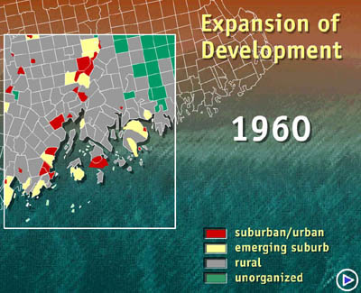 | 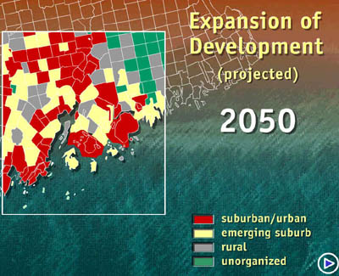
Figure 5 State Planning Office Land Use Analysis

- National population growth since the 1960s has shifted from urban to rural areas. Many rural areas are losing their historic character as housing subdivisions and commercial development overtake the countryside.
- High costs for land and housing are pushing affordable housing into Hancock County’s interior and into Washington County.
- Enclaves of higher-priced shorefront homes are more likely to be occupied only seasonally.

Implications
- Interior communities of Hancock County have very limited local resources to cope with problems associated with substance abuse.
- Not all drug problems are “urban” – illegal methamphetamine labs are often located in remote rural places.
- Hancock County’s long and complex shoreline is also a potential entry point for smugglers.

Economy

Hancock County is Prosperous but Highly Seasonal

Hancock County’s economy is growing as it transitions from resource-based fishing, farming, forestry and mining to service and retail. Seasonality has been a constant throughout. Tourism is particularly important in the new economy, with more than three million visits to Acadia National Park and growth along the coast from Castine to Gouldsboro. Demand for labor on Mount Desert Island increases dramatically during the summer and early autumn then plummets for the winter and spring months. Year-round employment is also increasing, particularly in health care, real estate and professional services.

- County Median Household Income has increased by 17% from $30,700 in 2000 to $36,000 in 2006. Incomes are highest on the coast.
- Hancock County and particularly Mount Desert Island have highly seasonal patterns economic activity driven by summer tourism and summer residents
- Seasonal economic tides result in labor shortages every summer and significant unemployment and under employment during the “off-season.”

Implications
- Rising incomes provide communities with resources to pay for schools, after school programs, community buildings and special events for all ages.
- Expanding economies offer employment opportunities and opportunities for recreation and entertainment that provide alternatives to substance abuse.
- Seasonality can contribute to substance abuse among the unemployed and marginally employed, particularly during extended periods of unemployment.
- Seasonal, temporary and part time employees are far less likely to have health insurance, access to employee assistance programs (EAP) and programs that treat substance abuse.
- The seasonal tourism creates demands for bars, exposing local children to alcohol promotions and use.

Conclusions
Hancock County is in transition with a growing, but aging population. The economy, once anchored by the production of blueberries, wood and wood products, granite and marine fisheries, has moved swiftly to being service-based with tourism, health care and research showing strong employment gains. Seasonality continues to be a challenge, with strong, even hectic, summer peaks in activity to long winters with relatively high unemployment rates. Growth is changing our communities, with more housing. As growth is driven by migration and primarily by migration of retirees, our substance abuse concerns cover the full life course.

Substance Abuse over the Life Course

We will now review risk and protective factors and substance abuse patterns over the life course. We will consider patterns for youth, adults and retirees as data permit. Each section will summarize factors that have been found to increase (risk) or reduce (protective) substance abuse and provide local and regional data indicating the current state of the county.

Youth

Protective and Risk Factors for Youth
Hancock County’s youth are in most respects similar to youth throughout Maine. Our rural and small town environment reduces somewhat their exposure to high risk behaviors associated with illegal drug use and crime. Most have the opportunity to attend small primary and secondary schools with favorable student to teacher ratios. Even in this environment, however, youth are at risk. The following table summarizes protective and risk factors gleaned from national research and adapted to the Hancock County environment.

Protective factors
Positively influenced through caring relationships with family, friends, school and community

School
Interest in schoolwork and success
Positive school experiences
Proud of accomplishments

Community and Peers
Good social skills
Positive reinforcement and opportunities for community involvement
Positive peer group

Family
Family rewards for positive involvement
Primary caregiver/parent interested in child’s school successes
Risk factors
Increase risk of substance abuse, particularly for this age group

Not interested in schoolwork or school success
Low commitment to school
Lower academic achievement
Poor family management
Person who lives in home who uses alcohol/drugs
Parental attitudes favorable to antisocial behavior

New factors emerge by grade 10

Friends’ use of drugs/alcohol
Intention to use drugs/alcohol
Perceived risk of drug use low
Early initiation of drug/alcohol use
Laws and norms favorable to drug use
Sources: A Parent’s Guide to: Your Infants and Child’s Resilience, Protection, and Threats
Healthy Peninsula 2004 Community Assessment
Maine Youth Drug and Alcohol Use Survey (MYDAUS) 2006

Indicators and Correlates of Substance Abuse – Youth to Young Adults

Recent data suggest there is reason to be concerned in Hancock County about substance abuse and related problems.

Substance Abuse
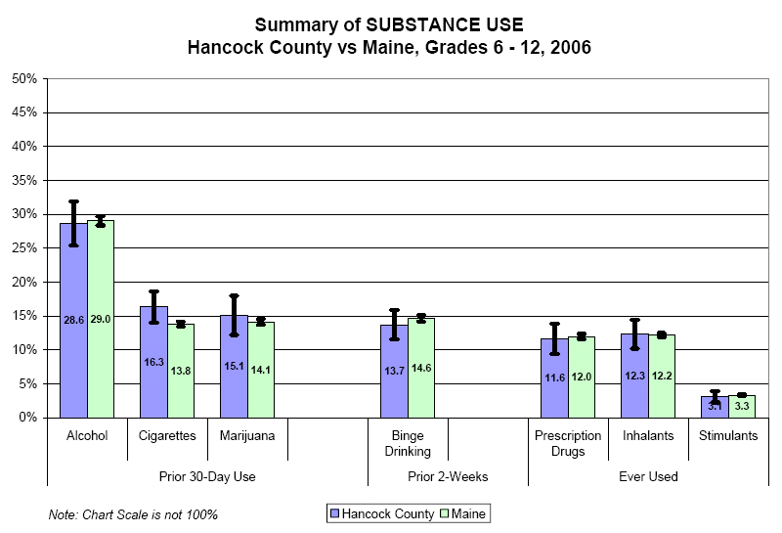

Figure 6Source: MYDAUS, 2006

Recent studies indicate that unsafe and illegal consumption of drugs and alcohol is flat or even rising after many years of decline. (MYDAUS) The 2006 Maine Youth Drug and Alcohol Use Survey (MYDAUS) indicates that that over 13% of students in grades six to twelve have engaged in binge drinking and / or use of illegal drugs, very similar to the state as a whole. Use of tobacco and marijuana is higher in Hancock County that the state.

Hancock County closely mirrors state incidence of binge drinking, with rates rising from onset in sixth grade to a peak in twelfth grade. Significant increases occur between 8th grade and 9th grade (7%), and 10th grade and 11th grade (9%). The first jump reflects the move of many Hancock County students into High School in 9th grade. The second jump may reflect increasing freedom associated with attaining driver’s licenses.

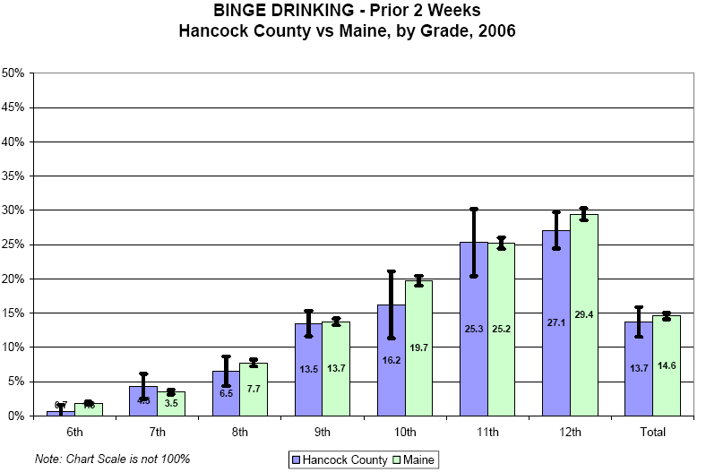

Source: MYDAUS, 2006

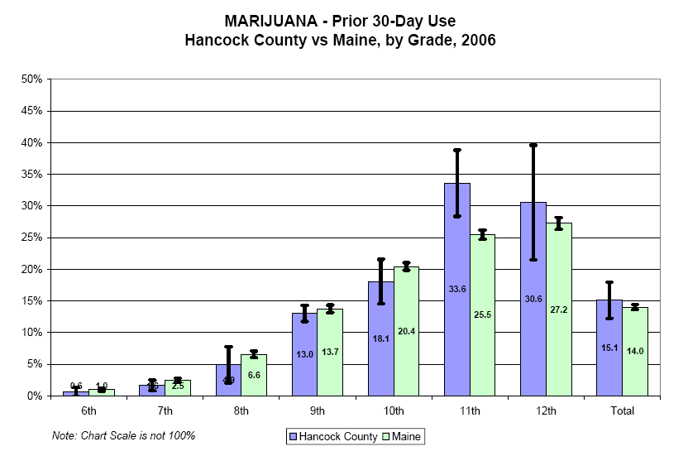
Source: MYDAUS, 2006

Hancock County reported use of marijuana among high school students appears to mirror the state, with an unusual spike in reported use by 11th grade students. Reported use increases significantly almost every year. The 15% increase in reported use mirrors a significant increase in reports of binge drinking between 10th and 11th grades. The decline in reported use by 12th graders is not common suggesting that the spike in 11th grade reported use may be a statistical anomaly. Whether or not this is the case, prevention efforts at all ages and all grades appear to be justified.

Illegal and High Risk Activity

Figure 7 Source: MYDAUS, 2006

Survey data suggest that Hancock County youth are engaging in high risk activities at rates similar to the state as a whole. Responses to the 2006 MYDAUS. Hancock County youth slightly exceed state averages for going to school under the influence of alcohol or drugs, violent behavior, drug related behavior and other crimes.

High School Completion
Concerns about student performance are supported by the data.

- Dropout rates in Hancock County high schools have remained 25% higher than state averages for the last decade.
- Hancock County high school Completion Rates (76%) are the lowest in Maine.
- Completion rates vary over time and across high schools. Among Hancock County’s seven schools that report completion rates, only Bucksport exceeded the state average.
- The connection between dropping out and substance abuse is cumulative, with substance abuse contributing to poor academic performance and dropping out in turn can contribute to substance abuse.

Substance Abuse and Other Criminal Activity
Crime reports for Hancock County suggest that problems with substance abuse were rising over the past decade. Additional effort on the part of law enforcement through the Substance Abuse Task Force in recent years contributed to higher arrest rates and may thus overstate actual substance abuse rates. In the long run, greater emphasis on enforcement is expected to prevent substance abuse and other high risk behaviors.

- Youth drug and alcohol arrests increased between 1991 and 2002
- A retail sales compliance check in Hancock County found that eight out of eight retailers sold alcohol to minors.

Adults

Indicators and Correlates of Substance Abuse –Adults

Protective and Risk Factors Adult (19+)

The Hancock County Team identified protective and risk factors for adults and summarize these below. As with youth, household stability is a key factor influencing adult substance abuse. A majority of adults spend a large portion of their time in the workplace. Employment instability is also a significant risk factor. For employed individuals, the workplace is also an important venue for prevention activities.

Protective Factors

Supportive family

Supportive peer group

Beliefs/attitudes about alcohol-self/peers

Consequences for misuse impact decision making when using alcohol
Risk Factors

Separation/divorce
Loss of spouse/partner
Change in Social Economic Status
Loss of or interruption of employment

Continuation of adverse effects from childhood
Beliefs/attitudes about alcohol-self/peers

Alcohol/drugs are easily accessible in home
High exposure
Source: Adapted from: Monitoring the Future National Survey Results On Drug Use, 1975-2005

Whereas data collected in high schools through MYDAUS, YRBS and other surveys provide detailed information about the knowledge, attitudes and practices of students, much less information is available specific to adult knowledge and attitudes.

We do know that substance abuse patterns are related to age, though much variation exists. Arrest and treatment data show a steady shift toward alcohol as a drug of choice with aging, though illegal drug use is persistent among persons who develop a chemical dependency, particularly for opiates.

Percent of Population Reporting Use

Alcohol Dependence/Abuse 12-17 18-25 26 or Older
in the past year
National 5.92 17.31 6.22
Maine 5.90 17.59 5.83
Region 7* 5.87 16.81 5.50

Any Drug Use Past Month**
National 11.19 19.81 5.67
Maine 13.71 25.01 6.33
Region (H, W, A, P) 12.67 21.24 5.59

Marijuana Use in Past Year
National 5.11 28.56 7.00
Maine 18.23 36.56 7.84
Region 7 15.66 (* - *) 6.35

Cocaine in Past Year
National 1.81 6.66 1.82
Maine 2.19 8.91 1.48
Region 7 2.38 7.71 1.30

Non-medical pain relievers
National 7.53 11.76 3.16
Maine 7.36 13.72 2.86
Region 7 6.73 12.23 2.96

* Region 7 includes Hancock, Washington, Aroostook and Piscataquis Counties
** Any Illicit Drug includes marijuana/hashish, cocaine (including crack), heroin, hallucinogens, inhalants, or any prescription-type psychotherapeutic used nonmedically.
Source: SAMSA 2002-2004 SubState Report of Substance Use & Serious Psychological Distress
Quick Facts

- Substance abuse rates peak in the young-adult population between ages 18 and 25, then decline over the life course.
- Adult substance abuse related crime rates closely mirror state patterns
- Alcohol related violations have remained nearly level, but continue to be the highest contributor to violations.
- Adult drug related violations are increasing.

- Arrest Rates are Rising Statewide
Drug Related Arrests are Rising Fastest

Between 1995 to 2004:
- Arrests for all crimes in Maine increased by 8.7%
- Arrests for drug abuse violations in Maine increased 65%
- Marijuana remains the primary drug of abuse in Maine
- Use and availability of cocaine, heroin, and diverted pharmaceuticals continue to increase.
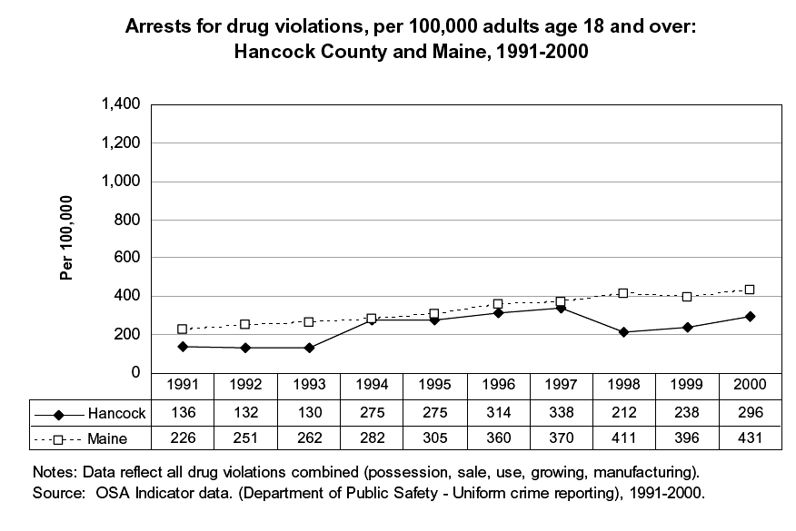
- Since 1995, arrests for other dangerous non-narcotics violations, including ecstasy and methamphetamine, have increased 248%.

Source: Maine Statistical Analysis Center Muskie School of Public Service
Maine Crime and Justice Brief Series: II

Other Adult Data indicating trends.

Seniors

Protective and Risk Factors Older Adult/Senior

Protective Factors

Access to resources, housing, healthcare
Social supports
Supportive family relationships
Knowledge of how to safeguard their health and skills to do so
Sense of purpose and identity
Lives independently with few supports

Risk Factors

Spouse/partner death
Income lower so self esteem may be lower and thus social status
Lower physical abilities
Declining health
Loss/reduction of hearing, sight, memory
Separated from children by distance
Loss of income if had to go into a retirement home or senior housing unit
Loss of social supports and activities
Isolation/lack of independence
Lack of transportation

Source: 2006-Central East Addiction Technology Transfer Center-The Danya Institute-Silver Springs, MD 20910
Source: Hancock County and Statewide Needs, Resources, and Readiness Assessment on Older Adult Alcohol Abuse--University of Maine Center on Aging-August, 2006

Indicators and Correlates of Substance Abuse –Seniors

Substance abuse patterns for seniors differs significantly from youth and adults. Concerns with most forms of criminal behavior decline along with incidence of use of illegal drugs like heroine, methamphetamine and cocaine.

Source: University of Maine Center on Aging “Hancock County and Statewide Needs, Resources, and Readiness Assessment on Older Adult Alcohol Abuse” (2006)

Alcohol and prescription drugs, both legal for retirees, are most readily available. A University of Maine Center on Aging study indicates that over the age of sixty-five well over 90% of all treatment substance abuse admissions were associated with alcohol.

Substance abuse concerns take different forms for seniors. Local support providers indicate that misuse of prescription drugs is more common than abuse. That is, seniors often follow complex directions for multiple medications. Some drugs conflict, some interfere with alertness and judgment and some are addictive. The onset of organic brain diseases like dementia can contribute to over medication. Another element of concern for seniors is misuse of their medications by family members or care givers, particularly drugs that have a high potential for abuse and dependence.

Prescriptions
- A high percentage of Schedule 2 prescriptions include narcotics and tranquilizers
- Doctor shopping and other techniques are employed by patients to sustain a supply of addictive drugs
- Electronic prescription monitoring is one way to improve tracking.

(Source: OSA Kim Johnson Presentation)

Additional detailed information is available in a recent study by the University of Maine Center on Aging titled “Hancock County and Statewide Needs, Resources, and Readiness
Assessment on Older Adult Alcohol Abuse” (2006)

SPEP Outreach Process and Findings

Our four healthy community coalition partners: Bucksport Bay Healthy Communities, Healthy Acadia, Healthy Peninsula and Union River Healthy Communities sponsored meetings throughout Hancock County to present and discuss our “State of the County” research. Each discussion emphasized the connections between local population characteristics, perceived substance abuse causes, patterns and consequences, and local assets for change. Following each presentation, a facilitated discussion was held about what to we can do to prevent substance abuse in Hancock County. The following is a quick summary of responses to the three principle questions addressed in these outreach meetings.

What patterns do you see?
- Age – substance abuse patterns vary across age groups
- Alcohol – is a primary concern
- Culture – substance abuse is integrated in the culture, particularly among some groups
- Economic status – unemployment contributes to SA, but SA affects all economic strata.
- Pain medications – over prescribed in some instances, and under prescribed in others
- Relationships – within families and social groups are important determinants of SA
- Stress – is a recurrent problem and may account for self medication and substance abuse

What are the Causes?
- Access – alcohol and drugs are very easy to obtain, even illegal drugs
- Boredom – is a problem, particularly for youth and young adults
- Family norms – substance abuse is often handed down from parents to children
- Isolation – Neglect – associated with substance abuse, particularly for youth and elderly
- Media (TV/Movies) – sends many pro-abuse messages and pharmaceutical promotions
- Pain Management / Workplace Injuries – can lead to opiate addiction
- Social Norms – widespread misperception among youth about actual prevalence of abuse
- Stress - is a recurrent problem and may account for self medication and substance abuse

What can we do?
- AA and other twelve step programs
- Access- restricting access to drugs
- Access - increasing access to alternatives
- Access – increasing access to care
- Attitudes – need to discourage pro-abuse attitudes
- Awareness of Programs in Schools
- Communication – parent to parent and parent-child
- Cost – increase prices of alcohol
- Culture and socialization
- Education – start early
- Enforcement - requires additional resources, should be fair and consistent across groups
- Family – needs to play a major role
- Media – needs to be more balanced
- Transportation – a key factor in dealing with boredom and access to alternatives

A Plan for Substance Abuse Prevention

Overview

We now turn from describing the state of the county to a plan for action to prevent future substance abuse across our population. This plan is very ambitious, with six goals, a larger number of “intervening variables”, strategies, critical resources and finally a process for engaging key partners.

Vision for Hancock County

Vision: “Substance abuse in Hancock County is prevented though a myriad of healthy alternatives available to all. People here choose a lifestyle without substance abuse.”
Maine Office of Substance Abuse

Vision: “A public untouched by substance abuse.”
Mission: “To prevent and reduce substance abuse and related problems by providing leadership, education, and support to communities and institutions throughout Maine.”*
Guiding Principles:
- Substance abuse prevention should be integrated with other Maine health prevention and wellness promotion activities.
- Maine’s substance abuse system should be data-driven, from the identification of problems and priorities, to monitoring and surveillance, to evaluating outcomes.
- Communities should be key partners in this initiative, and have flexibility in how they develop their substance abuse prevention infrastructure.

*Maine Office of Substance Abuse. State Prevention Plan. October 2004.

Mission: “The Hancock County Coalition will support prevention and intervention programs at the county and local level, emphasizing education, awareness campaigns, program coordination and enforcement to achieve positive public health outcomes.”

Hancock County reflects Maine as a whole. The Vision, Mission and Guiding Principles stated by the Maine Office of Substance Abuse are ambitious, but highly relevant for this county. Like OSA, the Hancock County Coalition will work to support county and local organizations in their efforts to prevent abuse of tobacco, alcohol, prescription and illegal drugs. A key to success will be setting attainable objectives with measurable results.

Goals, Intervening Variables and Strategies

The Hancock County coalition identified six areas of concern for substance abuse prevention. Listed in order of priority, these are 1) Underage Drinking, 2) High Risk Drinking, 3) Elder Alcohol Use and Abuse, 4) Illegal Drug Use, 5) Prescription Drug Abuse and 6) Marijuana Abuse.

The time frame for this plan is five years, and action on so many fronts in just five years will depend upon collaboration with a great many local, county and state partners. Current resource constraints will require Hancock County HMP and law enforcement agencies to address the top three priority areas first. As resources become available the remaining priorities will be included in the county action plan.

The Hancock County Plan employs a state-recommended format for goals, objectives and strategies. This format employs the following elements:

- Priority issues or problems relating to substance abuse
- Intervening variables: factors that have a track record for preventing substance abuse
- Strategies: activities designed to leverage intervening variables for prevention
- Resources: Organizations and programs that can assist in implementing strategies.

Three broad intervention strategies emerge for each of the six proposed prevention areas:

- Infrastructure – building up our substance abuse infrastructure through organizational development, capacity building and material support
- Implementation – putting science-based activities into action.
- Integration – building synergies across Hancock County’s many substance abuse prevention, interdiction, enforcement and treatment organizations through better communication and coordination.

Resource Matrix for Hancock County
The number of potential resources are too numerous to include in the summary charts for each intervening variable. In addition, most of our local and regional organizations are engaged on several fronts related to substance abuse prevention. Rather than present these organizations over and over for each specific strategy, this report includes a summary table or matrix that connects local and regional resources to the specific intervening variables. This table will be useful in preparing implementing programs to address single or multiple intervening variables. The matrix will be discussed in detail following our exposition of goals, intervening variables and strategies.

1. Underage Drinking
Preventing underage drinking is the highest priority in Hancock County. Regional and local data suggest that underage drinking and correlated problems like dropping-out of school and criminal activity have been growing in the county. The underage drinking task force, law enforcement, schools and local voluntary organizations are working together and are prepared to do more if we make this a priority and identify ongoing support for their programs.

The planning team identified six intervening variables that merit action to prevent underage drinking. The two charts below indicate these variables as well as strategies for each. The first panel outlines a three-prong model for prevention that increases knowledge, encourage non-punitive school policy and reduces retail access to alcohol. The second panel emphasizes broadening community involvement through collaboration with local organizations, adult modeling through media, linking safety to sobriety and workplace education, and seeking community collaboration in reducing youth social-access to alcohol. These strategies have been documented to work in a variety of environments, and many are used in Hancock County.

Goal

In five years the Hancock County SPEP collaborators will implement evidenced-based programs, strategies, and marketing campaigns that will result in a reduction of MYDAUS/YRBS 30-Day Prior Use of Alcohol by youth from grades 6 –12 by 10%.

Objectives

1. Hancock County members of the Downeast Public Health District and law enforcement agencies in Hancock County will convene and review all OSA SPF-SIG Workplan Objectives by 1/1/008 to determine commonalities and opportunities for coordination of programs and strategies.

2. An action plan that details regional and local programs and strategies to reduce underage drinking along with signed memorandums of understanding with key stakeholders will be developed and implemented by 4/1/08.

3. Members of the Hancock County SPEP Collaborative will meet quarterly to monitor and evaluate the progress of the action plan and make any necessary changes based upon information from the stakeholders.

4. Members will re-evaluate action plan programs and strategies based upon the results of the 2010 MYDAUS/YRBS results.

5. By 2012 SPEP collaborators will conduct a quantitative and qualitative evaluation on meeting the target goal of reducing underage drinking by 10%.

2. High Risk Drinking
The second priority noted by our team was curbing high risk drinking. This problem is directly related to legal and health consequences including driving under the influence, public intoxication, injuries through accidents and fighting, unprotected sex and health consequences of alcohol. Three intervening variables are noted in the following chart to address knowledge, normative behavior and law enforcement.

Goal

In five years the Hancock County SPEP collaborators will implement evidenced-based programs, strategies, and marketing campaigns that will result in a reduction of the binge drinking rate bu 10% as determined by the National Survey on Drug Use and Health.

Objectives

1. Hancock County members of the Downeast Public Health District and law enforcement agencies in Hancock County will convene and review all OSA SPF-SIG Workplan Objectives by 1/1/008 to determine commonalities and opportunities for coordination of programs and strategies.

2. An action plan that details regional and local programs and strategies to reduce high risk drinking along with signed memorandums of understanding with key stakeholders will be developed and implemented by 4/1/08.

3. Members of the Hancock County SPEP Collaborative will meet quarterly to monitor and evaluate the progress of the action plan and make any necessary changes based upon information from the stakeholders.

4. Members will re-evaluate the action plan programs and strategies based upon the results of the 2010 National Survey on Drug Use and Health.

5. By 2012 SPEP collaborators will conduct a quantitative and qualitative evaluation on meeting the target goal of reducing binge drinking by 10%.

3. Elder Alcohol Abuse
Elder Alcohol Use and Abuse, illegal drug use and prescription drug abuse carry approximately equal weight. Elder Alcohol Use/Abuse is listed as our third priority because we have a distinct set of resources to address these needs that need not conflict with progress on other fronts. Like the other priorities, some benefit will be derived from improving awareness or knowledge of the problem, particularly in the broader support community. This planning team supports building awareness through education and communication and coordinated efforts to conduct early intervention screenings. Critical support networks are particularly important for elderly that are confronting major changes in their lives.

Goal

In five years the Hancock County SPEP collaborators will implement evidenced-based programs, strategies, and marketing campaigns that will result in a reduction of the binge/chronic heavy drinking rate for adults over 64 years of age by 10%. As determined by the EMHS Household Survey

Objectives

1. Hancock County members of the Downeast Public Health District and law enforcement agencies in Hancock County will convene and review all OSA SPF-SIG Workplan Objectives by 1/1/008 to determine commonalities and opportunities for coordination of programs and strategies.

2. An action plan that details regional and local programs and strategies to reduce binge/chronic heavy drinking among the elderly along with signed memorandums of understanding with key stakeholders will be developed and implemented by 4/1/08.

3. Members of the Hancock County SPEP Collaborative will meet quarterly to monitor and evaluate the progress of the action plan and make any necessary changes based upon information from the stakeholders.

4. Members will re-evaluate action plan programs and strategies based upon the results of the Eastern Maine Household Survey results.

5. By 2012 SPEP collaborators will conduct a quantitative and qualitative evaluation on meeting the target goal of reducing binge/chronic heavy drinking by 10%.

4. Illegal Drug Use
Though Hancock County is rural and located relatively far from the nation’s epicenters of illegal drug activity, the county has been deeply affected by drug trafficking, abuse and addiction. In recent years the high prevalence of Oxycontin abuse in Washington and Hancock Counties has introduced a new generation to opiate addiction. Our local newspapers now regularly report arrests for trafficking and use of heroin as well as opiate-based pharmaceuticals. Efforts to expand methadone maintenance programs have met with local resistance, but forced greater awareness that the problem is serious.

Prevention strategies need to include education, interdiction, law enforcement and treatment. Interdiction and enforcement activities seek to reduce access to illegal drugs, while human services and education reduce demand, reduce social acceptance of illegal drugs and provide abusers with resources to quit using drugs.

5. Prescription Drug Misuse
National and state data indicate that abuse of prescription drugs is increasing, particularly among youth and young adults. The Hancock County Plan calls for a three-prong strategy for preventing this abuse, emphasizing increasing young adult’s knowledge about the risks and consequences of abusing prescription drugs, community and law enforcement efforts and use of mass communications to build community awareness. Finally, this plan supports a statewide investigation of pharmaceutical advertising that may contribute to prescription drug abuse.

6. Marijuana Prevention
Marijuana is considered to be a concern that requires a different strategy-mix from other illegal drugs. As with alcohol, marijuana has gained greater social acceptance than most drugs. The planning team proposes to increase knowledge of the health consequences of marijuana, emphasize social norms and reduce marijuana availability through parents and peers. This combination of information, motivation and reduced access will require collaboration between schools, parent groups and law enforcement.

Connecting Resources to Strategies

The Hancock County planning team identified over seventy-five organizations or groups of organizations that are our can be substance abuse prevention resources. Substance abuse prevention is not the primary mission of most organizations, but work that they do is related and significant.

Types of Organizations
These organizations can be classified in a variety of ways. For instance, many operate through specific channels. We noted five broad categories:

- Community based organizations
- Education
- Health and Substance Abuse
- Law Enforcement and emergency services
- Media and Business

Age Groups
Many of our resource organizations are also focused on particular age groups. As with the State of the County section of this plan, we noted the following age groups:

- Youth
- Young Adult
- Adult
- Seniors

Intervening Variables
The final dimension for our substance abuse resource organizations is to connect each with particular intervening variables and substance abuse prevention strategies.

- Underage Drinking - 9-20 Years Old
  - Knowledge of Health Risk
  - School Policy
  - Retail Access/Availability
  - Community Involvement
  - Adult Modeling
  - Social Access/Availability

- High Risk Drinking - 18-25 Year Olds
  - Knowledge of Health Risk
  - Norms
  - Law Enforcement

- Elder Alcohol Use and Abuse
  - Knowledge of Health Risks
  - Self Medication
  - Change of Environment

- Illegal Drug Use
  - Availability and Gateway Factors
  - Health/Mental Health
  - Norms

- Prescription Drug Misuse
  - Knowledge of Health Risk
  - Social Access/Availability
  - Advertising

- Marijuana
  - Knowledge of Health Risks
  - Norms
  - Availability

Resources
We have connected our 75+ organizations or types of organizations, as classified by type of intervention and age group of interest, to the intervening variables in a matrix included in the appendices. The purpose of the matrix is to provide planners and prevention leaders with a quick means for identifying potential partners to create or promote particular strategies. A sample of the full matrix is included below:

Cultural Competency
The Hancock County Substance Abuse Prevention program will benefit as our resource partners adopt new practices to meet growing diversity in our population. Characteristics associated with the capacity to work in a diverse cultural environment include:
- Value Diversity – accepting, respecting and celebrating cultural diversity
- Cultural Self–Assessment – learn how to work in a more diverse cultural environment
- Consciousness of the Dynamics of Cultural Interactions – recognizing how history and culture affect our relationships
- Institutionalization of Cultural Knowledge – creating a sustainable basis for cultural awareness
- Adapt to diversity – changing how we do things to respect our diverse cultures.

Hancock County Substance Abuse Prevention Resource Matrix | Organization |  |  |  |  |  |  |  |  |  | Cohort |  |  |  |  |  |  | High Risk Drinking
Resource | Community  Organization |  | Education |  | Health  & SA |  | Law  Enforcement |  | Media  and  Business |  | Youth |  | Young  Adult |  | Adult | Senior |  | Knowledge |  | Norms | Law
AA/NA |  |  |  |  | X |  |  |  |  |  |  |  | X |  | X | X |  | X
Acadia Family Center |  |  |  |  | X |  |  |  |  |  |  |  | X |  | X | X
Acadia Recovery Center |  |  |  |  | X |  |  |  |  |  | X |  | X |  | X | X |  | X
Care Volunteer Clearing House - Bucksport | X |  |  |  |  |  |  |  |  |  |  |  |  |  |  | X
Caregiver Resource Center | X
Chambers, Trade Organizations, Workplace Wellness, Rotary | X |  |  |  |  |  |  |  |  |  |  |  |  |  | X |  |  | X |  | X | X
Community Organizations, Friends and Neighbors, Neighborhood Watch | X |  |  |  |  |  |  |  |  |  | X |  | X |  | X | X |  |  |  |  | X
District Attorney |  |  |  |  |  |  | X |  |  |  | X |  | X |  | X |  |  |  |  |  | X
Downeast Sexual Assault (Palmer) |  |  |  |  | X |  |  |  |  |  |  |  | X |  |  |  |  |  |  | X
Early childhood networks | X |  | X |  |  |  |  |  |  |  | X |  | X
Education in the schools |  |  | X |  |  |  |  |  |  |  | X
Elder programs, provider network, Friendship Cottage | X |  |  |  |  |  |  |  |  |  |  |  |  |  |  | X
Emergency Responders |  |  |  |  |  |  | X |  |  |  | X |  | X |  | X | X
Food pantries | X |  |  |  |  |  |  |  |  |  |  |  | X |  | X | X
Hancock County Commissioners (Budget Committee) |  |  |  |  |  |  | X |  |  |  | X |  | X |  | X | X |  |  |  |  | X
Hancock County Drug Task Force / Drug Court |  |  |  |  |  |  | X |  |  |  | X |  | X
Hancock County Emergency Management Agency |  |  |  |  |  |  | X |  |  |  | X |  | X |  | X | X
Hancock County Home Care |  |  |  |  | X |  |  |  |  |  |  |  |  |  |  | X
Hancock County Jail Volunteers |  |  |  |  |  |  | X |  |  |  |  |  | X |  | X |  |  |  |  |  | X
Hancock County Medical Association |  |  |  |  | X |  |  |  |  |  | X |  | X |  | X | X
Hancock County Planning Commission | X |  |  |  |  |  |  |  |  |  | X |  | X |  | X | X
Hancock County Underage Drinking Task Force |  |  |  |  | X |  | X |  |  |  | X
Health Doctors, Providers, Nursing Associations, Home Health |  |  |  |  | X |  |  |  |  |  | X |  | X |  | X | X |  | X |  | X
Health Link |  |  |  |  | X |  |  |  |  |  |  |  |  |  | X | X
HOME, etc. | X |  |  |  |  |  |  |  |  |  | X |  | X |  | X | X
Hospice |  |  |  |  | X |  |  |  |  |  |  |  |  |  | X | X
Individual Substance Abuse Providers |  |  |  |  | X |  |  |  |  |  | X |  | X |  | X | X |  |  |  | X
Law enforcement Drug Enforcement/Underage Drinking Task Forces |  |  |  |  |  |  | X |  |  |  | X |  | X |  | X | X
Leagues – bowling, golf, fitness programs | X |  |  |  | X |  |  |  | X |  | X |  | X |  | X | X
Legislative Delegation |  |  |  |  | X |  | X |  |  |  | X |  | X |  | X | X |  |  |  |  | X
Libraries | X |  |  |  |  |  |  |  |  |  | X |  | X |  | X | X
Lighthouse Corporation | X
Maine Center on Aging |  |  |  |  | X |  |  |  |  |  |  |  |  |  |  | X
Maternal and Child health workers/parents |  |  |  |  | X |  |  |  |  |  | X |  | X
MDI Drug and Alcohol Group |  |  |  |  | X |  |  |  |  |  | X |  | X |  | X | X |  | X |  | X
Media and Press |  |  |  |  |  |  |  |  | X |  | X |  | X |  | X | X |  | X |  |  | X
Ministerial associations (Emily Taylor) | X |  |  |  |  |  |  |  |  |  | X |  | X |  | X | X
NE Harbor Nursing Association |  |  |  |  | X |  |  |  |  |  | X |  | X |  | X | X
Next Step |  |  |  |  | X |  |  |  |  |  | X |  | X |  |  |  |  | X |  | X
Nursing Association |  |  |  |  | X |  |  |  |  |  | X |  | X |  | X | X
Nursing Homes |  |  |  |  | X |  |  |  |  |  |  |  |  |  |  | X
Open Door Recovery |  |  |  |  | X |  |  |  |  |  | X |  | X |  | X |  |  | X |  | X
Office of Substance Abuse |  |  |  |  | X |  |  |  |  |  | X |  | X |  | X | X |  |  |  | X
Parents - Organized groups | X |  |  |  |  |  |  |  |  |  | X
Pharmacies - Prescription Disposal Program |  |  |  |  | X |  |  |  |  |  | X |  | X |  | X | X
Retailers, Restaurants, Bars, Hotels |  |  |  |  |  |  |  |  | X |  |  |  | X |  | X | X |  | X |  | X | X
School COA |  |  | X |  |  |  |  |  |  |  |  |  | X |  |  |  |  |  |  |  | X
School coaches, faculty, staff, board-curriculum, service learning |  |  | X |  |  |  |  |  |  |  | X
School Ellsworth Higher Education Center |  |  | X |  |  |  |  |  |  |  |  |  | X |  | X |  |  |  |  |  | X
School leadership / Policies - Consistency |  |  | X |  |  |  |  |  |  |  | X
School MMA |  |  | X |  |  |  |  |  |  |  |  |  | X |  |  |  |  |  |  |  | X
School nurses, policy leaders, coaches |  |  | X |  |  |  |  |  |  |  | X
School nurses/curriculum development |  |  | X |  |  |  |  |  |  |  | X
School Parent/Teacher Organizations Take Home Pamphlet |  |  | X |  |  |  |  |  |  |  | X
School PTA |  |  | X |  |  |  |  |  |  |  | X
School Resources Officers – School Policies |  |  | X |  |  |  |  |  |  |  | X
School Social Norms curriculum |  |  | X |  |  |  |  |  |  |  | X
School Volunteer Programs – Senior Mentors |  |  | X |  |  |  |  |  |  |  | X |  |  |  |  | X
Senior Centers / Meals for Me | X |  |  |  |  |  |  |  |  |  |  |  |  |  |  | X
Senior College |  |  | X |  |  |  |  |  |  |  |  |  |  |  |  | X
Senior Housing | X |  |  |  |  |  |  |  |  |  |  |  |  |  |  | X
Shelters | X |  |  |  |  |  |  |  |  |  | X |  | X |  | X | X
Subsidized Housing programs | X |  |  |  |  |  |  |  |  |  |  |  | X |  | X | X
Substance Abuse Counselors |  |  |  |  | X |  |  |  |  |  | X |  | X |  | X | X
Town Officers/Code Enforcement | X |  |  |  |  |  |  |  |  |  |  |  | X |  | X
Transportation (Island Connect, Comm Connect, DTI, WHCA) | X |  |  |  |  |  |  |  |  |  | X |  |  |  |  | X
Visiting Nurses |  |  |  |  | X |  |  |  |  |  |  |  |  |  |  | X
WHCA (RX, Etc.) | X |  |  |  | X |  |  |  |  |  |  |  |  |  | X | X
YMCA | X |  |  |  |  |  |  |  |  |  | X
Young Adult Employment Services |  |  |  |  |  |  |  |  | X |  |  |  | X |  |  |  |  | X |  | X
Youth Advocacy Networks | X |  |  |  |  |  |  |  |  |  | X
Youth organizations | X |  |  |  |  |  |  |  |  |  | X
Youth programs Camps, YMCA, YAP, BBS | X |  | X |  |  |  |  |  |  |  | X |  | X |  | X | X
Hancock County Substance Abuse Prevention Resource Matrix |  | Underage Drinking |  |  |  |  |  |  |  |  |  |  |  | Elder Alcohol Abuse
Resource |  | Knowledge of  Health Risk |  | School  Policy |  | Retail  Access |  | Community |  | Adult  Modeling |  | Social  Access |  | Knowledge |  |  | Self  Medication |  | Change of  Environment
AA/NA |  | X |  |  |  |  |  | X |  | X |  |  |  | X |  |  |  |  | X
Acadia Family Center
Acadia Recovery Center
Care Volunteer Clearing House - Bucksport |  |  |  |  |  |  |  |  |  |  |  |  |  |  |  |  |  |  | X
Caregiver Resource Center |  |  |  |  |  |  |  |  |  |  |  |  |  | X
Chambers, Trade Organizations, Workplace Wellness, Rotary |  |  |  |  |  |  |  | X |  | X |  |  |  | X |  |  |  |  | X
Community Organizations, Friends and Neighbors, Neighborhood Watch |  |  |  |  |  |  |  | X |  |  |  |  |  |  |  |  |  |  | X
District Attorney
Downeast Sexual Assault (Palmer) |  |  |  |  |  |  |  |  |  |  |  | X
Early childhood networks |  |  |  |  |  |  |  |  |  | X
Education in the schools
Elder programs, provider network, Friendship Cottage |  |  |  |  |  |  |  |  |  |  |  |  |  | X
Emergency Responders |  |  |  |  |  |  |  |  |  | X
Food pantries |  | X |  |  |  |  |  |  |  |  |  |  |  | X
Hancock County Commissioners (Budget Committee)
Hancock County Drug Task Force / Drug Court
Hancock County Emergency Management Agency
Hancock County Home Care |  |  |  |  |  |  |  |  |  |  |  |  |  | X
Hancock County Jail Volunteers
Hancock County Medical Association |  |  |  |  |  |  |  |  |  |  |  |  |  | X
Hancock County Planning Commission
Hancock County Underage Drinking Task Force |  |  |  |  |  | X
Health Doctors, Providers, Nursing Associations, Home Health |  | X |  |  |  |  |  |  |  | X |  |  |  |  |  |  | X
Health Link |  |  |  |  |  |  |  |  |  |  |  |  |  |  |  |  |  |  | X
HOME, etc. |  | X
Hospice |  |  |  |  |  |  |  |  |  |  |  |  |  | X
Individual Substance Abuse Providers
Law enforcement Drug Enforcement/Underage Drinking Task Forces |  |  |  |  |  | X |  |  |  |  |  | X
Leagues – bowling, golf, fitness programs |  |  |  |  |  |  |  |  |  |  |  |  |  |  |  |  |  |  | X
Legislative Delegation
Libraries
Lighthouse Corporation
Maine Center on Aging
Maternal and Child health workers/parents |  |  |  |  |  |  |  |  |  | X
MDI Drug and Alcohol Group
Media and Press |  |  |  |  |  | X |  |  |  |  |  | X |  |  |  |  |  |  | X
Ministerial associations (Emily Taylor)
NE Harbor Nursing Association |  |  |  |  |  |  |  |  |  |  |  |  |  |  |  |  |  |  | X
Next Step
Nursing Association |  |  |  |  |  |  |  |  |  |  |  |  |  | X
Nursing Homes |  |  |  |  |  |  |  |  |  |  |  |  |  |  |  |  |  |  | X
Open Door Recovery
Office of Substance Abuse
Parents - Organized groups |  |  |  | X
Pharmacies - Prescription Disposal Program
Retailers, Restaurants, Bars, Hotels |  |  |  |  |  | X |  |  |  |  |  |  |  |  |  |  | X
School COA
School coaches, faculty, staff, board-curriculum, service learning |  | X |  | X
School Ellsworth Higher Education Center
School leadership / Policies - Consistency
School MMA
School nurses, policy leaders, coaches
School nurses/curriculum development
School Parent/Teacher Organizations Take Home Pamphlet
School PTA
School Resources Officers – School Policies
School Social Norms curriculum
School Volunteer Programs – Senior Mentors |  |  |  |  |  |  |  |  |  |  |  |  |  |  |  |  |  |  | X
Senior Centers / Meals for Me |  |  |  |  |  |  |  |  |  |  |  |  |  |  |  |  |  |  | X
Senior College |  |  |  |  |  |  |  |  |  |  |  |  |  |  |  |  |  |  | X
Senior Housing |  |  |  |  |  |  |  |  |  |  |  |  |  |  |  |  |  |  | X
Shelters
Subsidized Housing programs |  |  |  |  |  |  |  |  |  |  |  |  |  |  |  |  |  |  | X
Substance Abuse Counselors
Town Officers/Code Enforcement
Transportation (Island Connect, Comm Connect, DTI, WHCA) |  |  |  |  |  |  |  |  |  |  |  |  |  |  |  |  |  |  | X
Visiting Nurses |  |  |  |  |  |  |  |  |  |  |  |  |  | X
WHCA (RX, Etc.) |  |  |  |  |  |  |  |  |  |  |  |  |  |  |  |  |  |  | X
YMCA |  | X |  |  |  |  |  |  |  |  |  |  |  |  |  |  |  |  | X
Young Adult Employment Services
Youth Advocacy Networks |  |  |  | X |  |  |  |  |  |  |  | X
Youth organizations |  |  |  |  |  |  |  | X
Youth programs Camps, YMCA, YAP, BBS |  |  |  |  |  |  |  | X |  |  |  |  |  |  |  |  |  |  | X

Hancock County Substance Abuse Prevention Resource Matrix | Illegal Drug Use |  |  | Prescription Drug Abuse |  |  | Marijuana
Resource | Availability | Health/Mental  Health | Norms | Knowledge | Social  Access | Advertising | Knowledge | Norms | Availability
AA/NA |  | X |  | X |  |  | X
Acadia Family Center
Acadia Recovery Center |  | X
Care Volunteer Clearing House - Bucksport
Caregiver Resource Center
Chambers, Trade Organizations, Workplace Wellness, Rotary |  |  |  | X |  |  | X |  | X
Community Organizations, Friends and Neighbors, Neighborhood Watch | X |  |  |  | X
District Attorney
Downeast Sexual Assault (Palmer)
Early childhood networks
Education in the schools | X
Elder programs, provider network, Friendship Cottage |  |  |  | X |  | X
Emergency Responders
Food pantries |  |  |  | X
Hancock County Commissioners (Budget Committee)
Hancock County Drug Task Force / Drug Court | X
Hancock County Emergency Management Agency | X
Hancock County Home Care
Hancock County Jail Volunteers
Hancock County Medical Association
Hancock County Planning Commission | X |  |  |  | X
Hancock County Underage Drinking Task Force
Health Doctors, Providers, Nursing Associations, Home Health |  | X |  | X
Health Link
HOME, etc.
Hospice
Individual Substance Abuse Providers
Law enforcement Drug Enforcement/Underage Drinking Task Forces | X |  |  |  | X |  |  | X | X
Leagues – bowling, golf, fitness programs
Legislative Delegation |  |  |  |  |  | X
Libraries |  |  |  | X
Lighthouse Corporation |  |  | X
Maine Center on Aging |  |  |  | X
Maternal and Child health workers/parents
MDI Drug and Alcohol Group
Media and Press |  |  | X
Ministerial associations (Emily Taylor) |  |  |  | X
NE Harbor Nursing Association
Next Step
Nursing Association
Nursing Homes
Open Door Recovery |  | X |  |  |  |  | X
Office of Substance Abuse |  |  |  |  | X
Parents - Organized groups
Pharmacies - Prescription Disposal Program |  |  |  | X
Retailers, Restaurants, Bars, Hotels | X
School COA
School coaches, faculty, staff, board-curriculum, service learning
School Ellsworth Higher Education Center
School leadership / Policies - Consistency |  |  |  |  |  |  |  | X
School MMA
School nurses, policy leaders, coaches |  |  |  | X
School nurses/curriculum development |  | X
School Parent/Teacher Organizations Take Home Pamphlet |  |  | X
School PTA |  |  |  |  | X
School Resources Officers – School Policies | X
School Social Norms curriculum |  |  |  |  |  |  |  | X
School Volunteer Programs – Senior Mentors
Senior Centers / Meals for Me
Senior College
Senior Housing
Shelters |  | X
Subsidized Housing programs
Substance Abuse Counselors |  | X |  |  |  |  | X
Town Officers/Code Enforcement | X
Transportation (Island Connect, Comm Connect, DTI, WHCA)
Visiting Nurses
WHCA (RX, Etc.) |  |  |  | X | X
YMCA
Young Adult Employment Services
Youth Advocacy Networks
Youth organizations
Youth programs Camps, YMCA, YAP, BBS

Implementation

Creating a Work Plan
This plan identifies broad concerns, goals and strategies. Implementation of the plan will require considerable coordination across numerous organizations. As the state transitions to a regional, and for us two-county, model for public health and substance abuse prevention this general document will help to define important stakeholders and priority concerns.

Uncertainty about the eventual formation of prevention networks makes more detailed planning difficult. Clearly a detailed work plan that identifies specific objectives with a timeline and evaluation criteria is needed in order to marshal resources and orchestrate activities. This critical next step should be pursued during the 2007-2008 fiscal year. The elements of a work plan following the Maine Strategic Prevention Framework (SPF) Logic Model include strategies, short, intermediate and long term outcomes and evaluation criteria.

While this plan falls short of providing a detailed work plan, the team has identified critical partners in our effort to prevent substance abuse. Most of these organizations, included in the resource matrix, will be called-upon as specific opportunities and programs arise. A core group of partners, engaged in the planning effort, are committed to continue the program planning and development effort as described in the following memoranda of understanding. These partners include:

- Hancock County Planning Commission
- Bucksport Bay Healthy Communities
- Healthy Acadia
- Healthy Peninsula
- Union River Healthy Communities
- Hancock County Sheriff’s Office

The Healthy Hancock Coalition has served as an umbrella organization coordinating coalitions that in turn include many of the key partners in our effort to prevent substance abuse. A 2005 organizational chart for Healthy Hancock is included in the appendix. Individuals names in the chart change frequently, but the organization structure has remained stable for several years.

Sample Memoranda of Understanding
Agency
Organization Name/Title
City, State, and Zip Code
MEMORANDUM of UNDERSTANDING
BETWEEN
THE AGENCY AND SERVICE PROVIDER
SUBJECT: Agreement to collaborate in substance abuse prevention efforts in Hancock County
1. Purpose. This agreement defines the activities of participating organizations with the goal fo preventing substance abuse in Hancock County.

2. Reference: List the references that are directly related to the MOU.

3. Problem: Statement of the problem, to include a brief background

4. Scope. Statement specifying the area of the MOU

5. Understandings, agreements, support and resource needs. List the understandings, agreements, support and resource needs, and responsibilities of and between each of the parties or agencies involved in the MOU.

6. Specify a certain contracting period.
7. Specify monetary and performance terms. Explain payment rates with all rates agreed to by both parties. Designate specific time frames and dollar amounts to be paid upon completion of each identifiable task.

8. Include a monitoring component to determine contract compliance. If the terms of the MOU are not being fulfilled, allow for a termination clause.

9. Effective date
Signed |  | Signed
(Date) |  | (Date)

Appendices

Appendix 1: Resource-Intervening Variable Matrix – See attached form and Excel Spreadsheet

Appendix 2: Memoranda of Understanding

Appendix 2: Health Hancock (Circ. 2005 – Some revisions required)
Healthy Hancock
Healthy
Maine
Partnerships
Coastal Hancock Healthy Communities
Healthy Acadia
Healthy Peninsula Project
Gouldsboro, Sorrento, Sullivan, Steuben, Winter Harbor
Towns
Ellsworth, Aurora, Hancock, Dedham, Otis, Osborne, Mariaville, Franklin, Amherst, Waltham, Easbrook, Great Pond
Bucksport, Orland, Verona Island, Prospect
Trenton, Lamoine, Bar Harbor, Mt. Desert, Swan’s Island, Southwest Harbor, Tremont, Frenchboro
Blue Hill, Sedgwick, Brooklin, Castine, Penobscot, Surry
Deer Isle, Stonington
Union River
Healthy
Communities

Bucksport Bay
Healthy
Communities

Healthy
Acadia
Healthy
Peninsula
Project
Healthy
Island
Healthy
Community
Coalitions
Organization Partners
Hancock Co
Planning
Commission
Jim Fisher - Planner
Univ Me Cooperative Extension
Joyce Kleffner - Nutritionist
Committees
Downeast Health Services
Ellsworth School Dept

MCMH

Bucksport School Dept

MDI Hospital

School Union 98

Blue Hill Memorial Hospital
School AU
76

Helena Peterson – Director

Valerie Kenney – Program Assistant

Steven Johndro – Comm Hlth Specialist (& OneME Coord)

Emilia Bachrach – Youth Coord/VISTA
Kelly Fitzgerald – School Hlth Coord

Katrina Kane – Supt of Schools
Iris Simon – Health Educator

Doug Jones - CEO
Kate Yerxa – School Hlth Coord

Marc Curtis – Supt of Schools
Town of Bucksport

Mary Jane Bush – Health Planner BBHC
Doug Michael – Director

Vacant – Health Educator

Irene Greene-Murphy – Substance Abuse Coord (OneME)
Jenny Gott, RN – School Hlth Coord
Barbara Peppey – Director

Donna Madonna – Program Asst

Josephine Jacobs – VISTA Youth Coord

Linda Jaffe – PATH/OneME Coord
Meredith Gray – Director, Healthy Island

Heather Barton – Lindloff – School Hlth Coord
Evaluation
&
Research
Jim Fisher - Chair
Policy
Mary Jane Bush - Chair
Jenny Gott - Chair
Education
State Level Partners
Bureau of Health
Healthy Maine Partnerships
OSA – OneME

ME Network of Healthy Communities
Dora Ann Mills MD Dir
Commissioner Nickolas
Cathy Ramaika-Project Officer
Andy Finch-Senior Prog Officer
Barbara Leonard-Director
Lee Anne Dodge – OneME Coordinator
Mary Beth Welton – Pgm Manager (PTM)
Chris Lyman, MS, CHES – Comm Hlth Specialist (Community Health Program)

